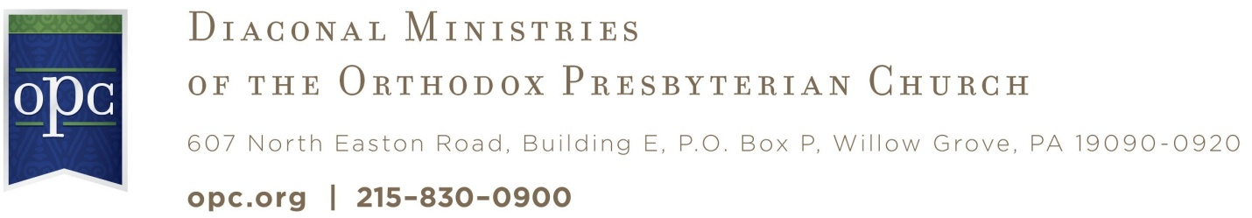

Questionnaire

Part I - Overview of Diaconal Work

- What training did you have to prepare you for the diaconate?

- Was it adequate?

- Why or Why not?

- What areas do you wish you had more preparation for before becoming a deacon?

- What books or resources have you found to be helpful for understanding what the diaconate is and helping you to fulfill your ministry as a deacon?

- What percentage of your church budget is given for diaconal ministry?

- Do you regularly have needs that exceed the balance in your deacon funds?

- What are the most frequent ways your deacons are called upon by your congregation (eg, people out of work, hospital visitation, helping those in poverty, budget training and counseling, etc.)?

- What are the most frequent ways your deacons are called upon by people in the community? (eg, people out of work, hospital visitation, helping those in poverty, budget training and counseling, etc.)?

- How does the session interact with the deacons in the process of doing diaconal work?

- How is the session involved in the lives of people you help?

- Does your diaconate have a policy notebook dealing with different issues?

- If yes, would you be willing to share this with the wider church?

- If not, would a policy notebook be helpful?

- If the CDM were to create a policy notebook, giving suggestions and resources to deacons as a help with issues they face, what subjects would you request be addressed?
PART II - Challenges Deacons face: (Multiple choice?)

- Do you feel frustrated in your diaconal work?

- What are your greatest challenges/difficulties in your work as deacons?

- Are you excited about your calling?

- Do you understand your calling?

- Do you feel that you have an active and effective diaconal ministry? (rate from 1 to 10?)

- In what ways does your diaconal ministry need to grow and develop (eg, resources, such as, finances, manpower, guidance, ideas)?

- Is your diaconal ministry something that others could learn from as a model? If so, how?

- In what areas would you like to learn from other deacons?

- In what ways do you think we could grow in our diaconal work as presbyteries or as a denomination?

PART III - Networking for Diaconal Ministry (rate from 1 to 10?)

- Does your presbytery have a well organized Diaconal Committee?

- Is your diaconal ministry well connected to your presbytery diaconal committee?

- Do you know the duties and functions of your presbytery’s diaconal committee?

- Do you have any contact with this committee?

- Is your local diaconal ministry well connected to the Committee on Diaconal Ministries of the denomination?

- Do you know who to contact if your needs go beyond the scope of your local congregations?

Beyond the scope of your presbytery?

- Do you feel it would be helpful to have something in place to facilitate presbytery diaconal ministries as well as denominational diaconal ministries?

- Do you have any suggestions how can we develop that network?

- Are there specific needs or challenges in your presbytery? For example: Higher than average number of elderly, higher rate of poverty, extreme weather conditions, higher chance of natural disasters, etc.

- How could the Committee on Diaconal Ministries (CDM) be a better resource or help to the deacons of local churches?

PART IV - Diaconal Work on the Mission Field [Case Study for Missionary deacons?]

- Are you currently promoting short-term mission/diaconal projects at home or on foreign mission fields?

- Are you aware of the role of missionary deacons in helping our missionaries in their work in other countries?

- Would it be helpful to have more information on short term projects in our denomination?

______________________________________________________________________________________________________________

Correspondence or Inquiries

Committee on Diaconal Ministries
Rev. Ronald Pearce, Secretary
Church of the Covenant
319 Blau Road
Hackettstown, NJ 07840-5227
Phone: 908-850-8910
Email: churchofthecovenant@earthlink.net
Financial Contributions

Orthodox Presbyterian Church
Committee on Diaconal Ministries
Box P
Willow Grove, PA 19090-0920
Phone: 215-830-0900

Please be sure to clearly designate contributions.

