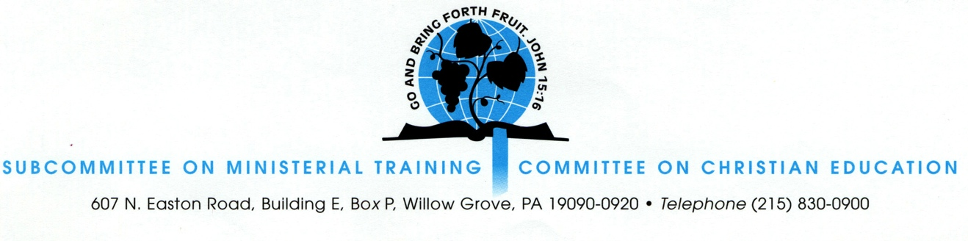

2025 Shiloh Institute Application Form

DUE BY APRIL 15, 2025

(This is a Word document. Please type in the requested information and paste, or attach, it to an e-mail sent to the Rev. Gregory Reynolds, Director of the Institute, at: greg.reynolds@opc.org.)

- Personal information

Name: _____________________________
Address: _______________________________________________________________
Email: _____________________________
Phone numbers(s): __________________________________
Date of Birth: ___________________
Educational background: ___________________________________________________
________________________________________________________________________
________________________________________________________________________
Status of Ministerial Candidacy:______________________________________________
Ministerial Experience (if any): ______________________________________________
Church name: ____________________________________________________________
Address: ________________________________________________________________
Church e-mail: ___________________________________________________________

Pastor or elder filling out recommendation: ___________________________________
E-mail address: _______________________
Phone number(s): ____________________________________

2. Pastoral Reference

Please ask your pastor or an elder from your church to submit a reference on your behalf to the email address above. The reference should explain why he is recommending you to attend the Summer Institute, and it should include any details that might bear on your candidacy in the selection process.

3. Essay

Describe (in 500 to 1000 words) your understanding of the nature of Presbyterianism and your personal commitment to be an Orthodox Presbyterian minister.

